ENGG 408
Team Project Individual Model
Sprint 4 Individual Model Summary: Regularized Logistic Regression

Inmer Jimenez

Individual Model Summary: Regularized Logistic Regression
For my individual Sprint 4 model, I tested a regularized logistic regression classifier for our trade stock trend prediction project. The goal of this model was to determine whether a simple course base classification method could identify short term market trends using a 30 minutes OHLCV/VWAP candle data. The model used the team’s based code and dataset, which includes multiple high volume stocks such as AMZN, TSLA, MSFT, GOOG, JPM, BA, UNH, XOM, and GM. Each candle was classified into these three labels: up_trend, down_trend, or no_trend.
I selected logistic regression because it connects directly to the Sprint 2 material on probability discriminative models. Since financial data can get noisier than expected, I used L2 regularization to help reduce overfitting. The input features were open, high, low, close, volume, trade_count, vwap, day_of_week, hour, and minute. Before training, the features were standardized using StandardScaler, and the dataset was split into training and testing sets using an 80/20 split.
This version of the model produced an accuracy of 68.78%, but the confusion matrix showed that this result was misleading because the model was predicting every test sample as no_trend. Since the majority of the class in the dataset was no_trend the model learned that this was the safest way to predict. As a result the precision, the recall and the F1-score for both up_trend and down_trend were set to 0. To address this issue, I added classe_weight=’balanced’ to the logistic regression model, this gave more importance to the other class that the model did not consider before.
After making this change the accuracy decreased significatively to 44.72%, but the model began predicting all three classes. The balanced model achieve an F1-score of 0.23 for down_trend, 0.59 for no_trend, and 0.26 for up_trend.

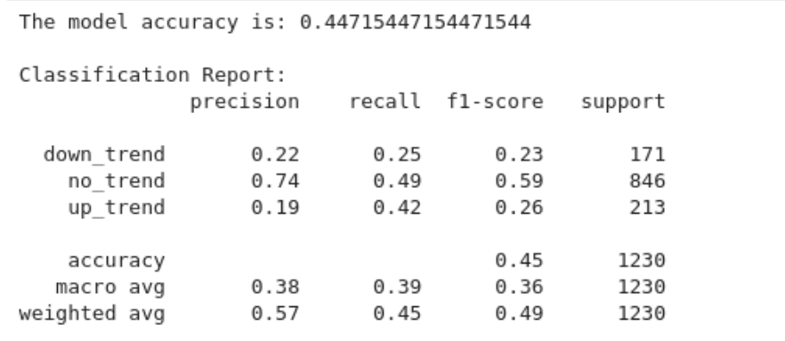
The confusion matrix also showed improvements, the model identified some trend cases, 89 up_trend samples and 43 down_trend samples. However, the model also misclassified several no_trend samples as trend classes.
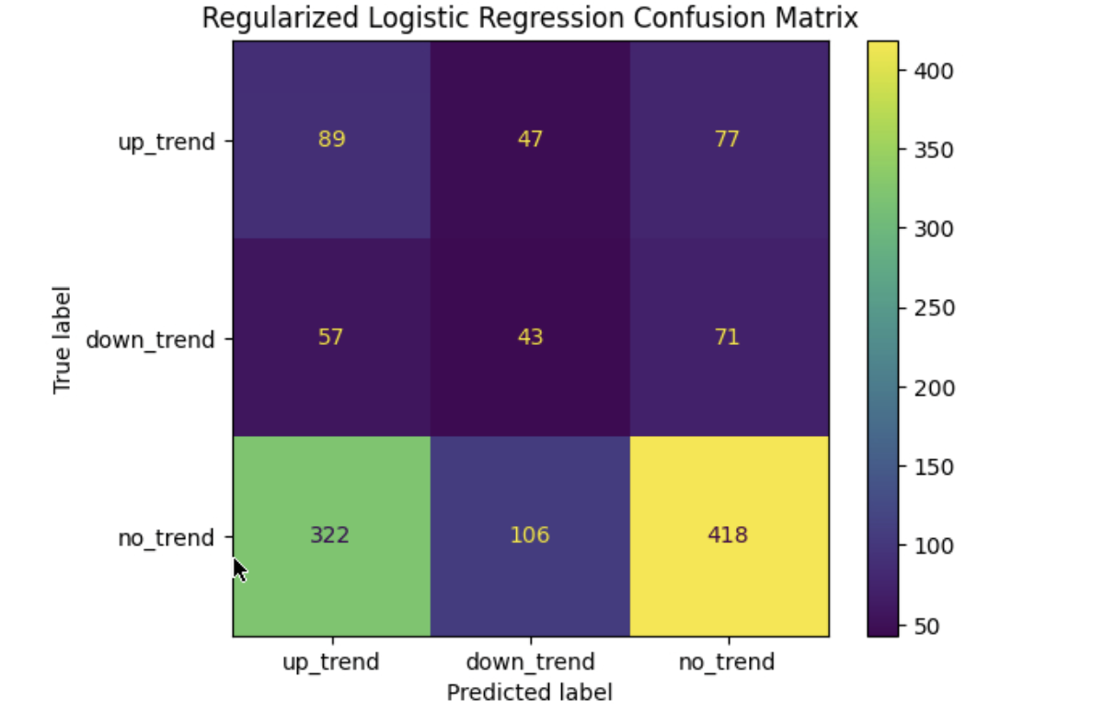
In conclusion, the balanced regularized logistic regression model did not perform strong enough to be considered for the final model for Sprint 5. The model achieved an accuracy of 44.72% which shows that it struggled to classify the trend labels correctly. Based on these results, I think our team should try another model that can perform better and predict the trend classes more accurately.

